Name: M.Witty
Roll: 2420030759

Git and GitHub (Commits)
- Install Git on the system.
- Open Command Prompt or Git Bash.
- Create a new project folder.
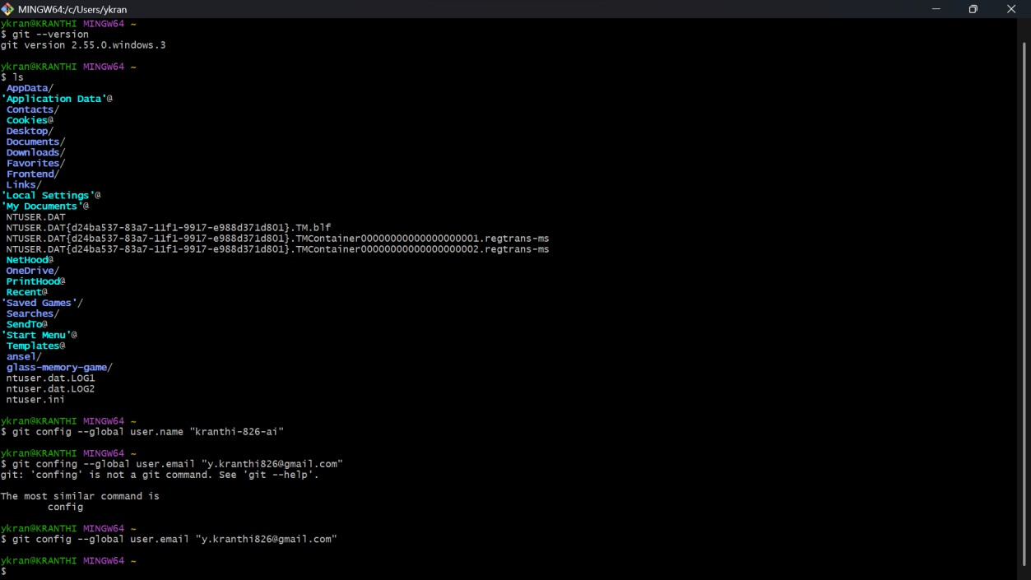
- Open the folder in the terminal.

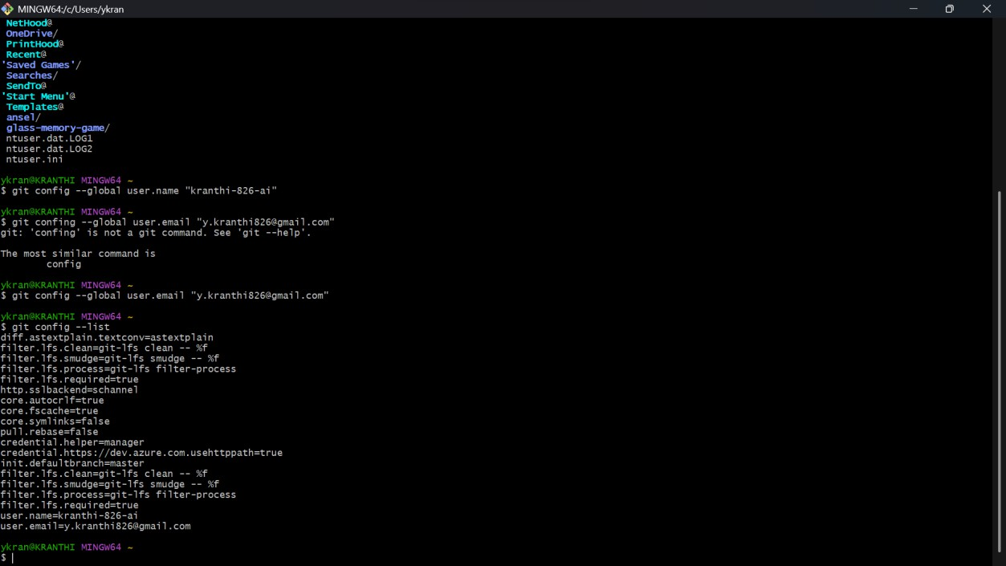
- Initialize Git using git init.

- Open the folder in the terminal.
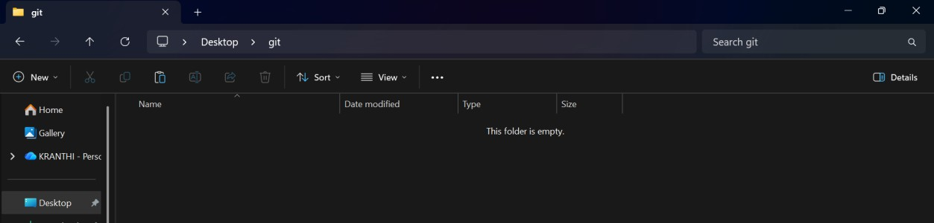
- Initialize Git using git init.
- Create or add project files.

- Check the files using git status.
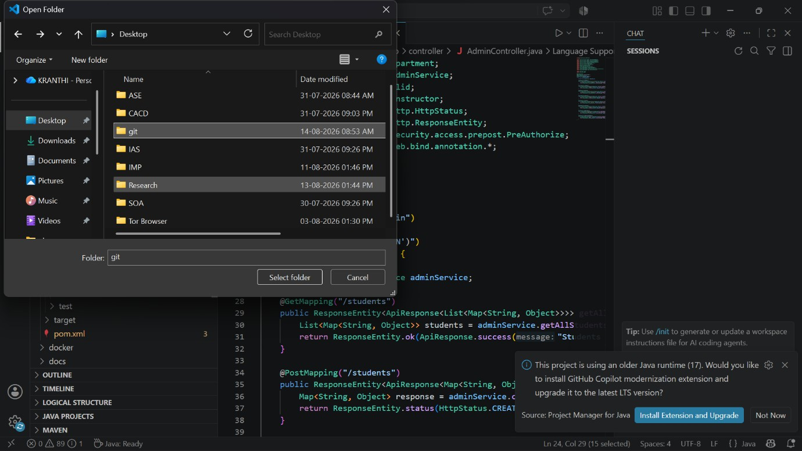

- Add the files using git add .
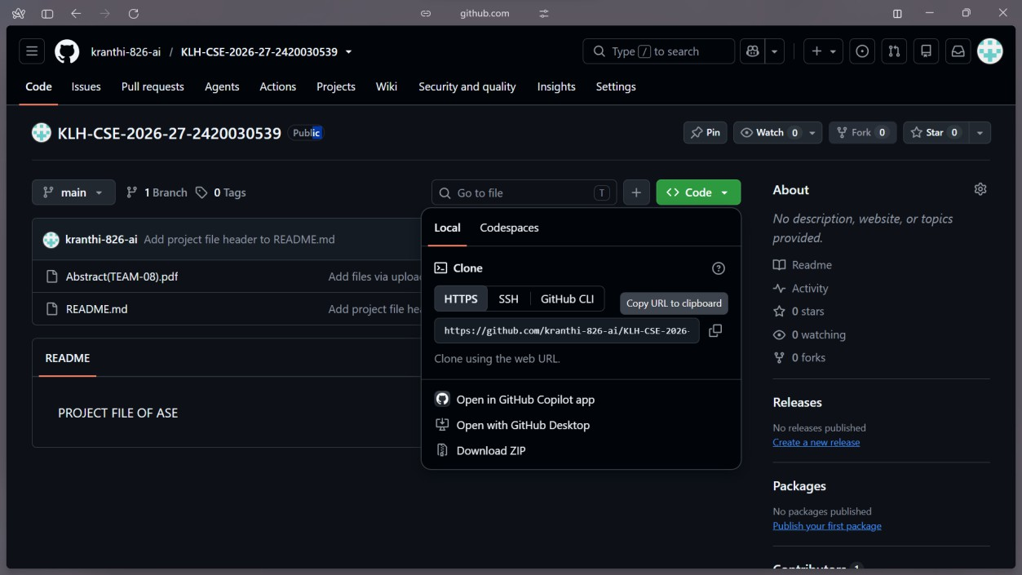
- Create a commit using git commit -m "Initial commit"

Create a repository on GitHub.

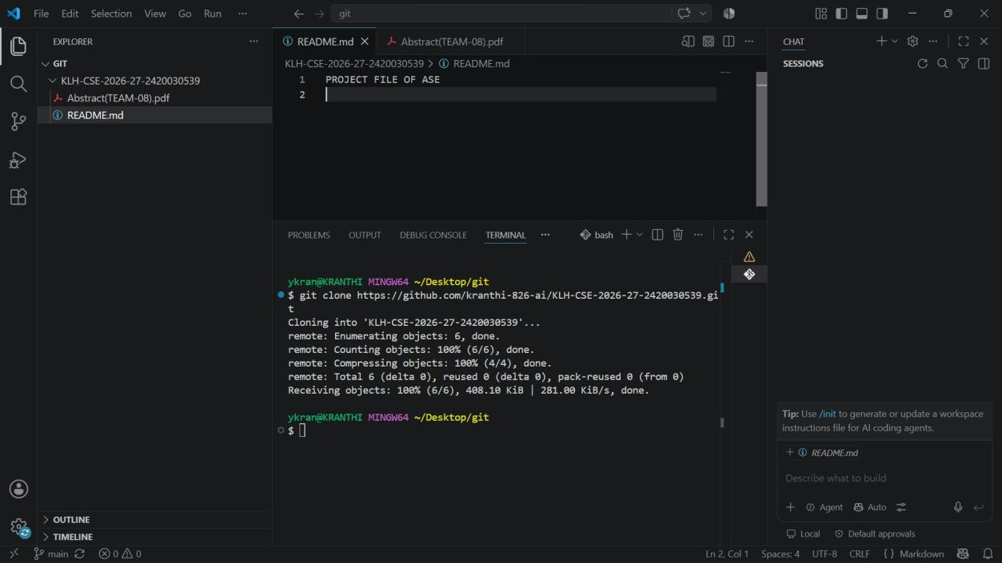
- Connect the local repository with GitHub using git remote add origin.

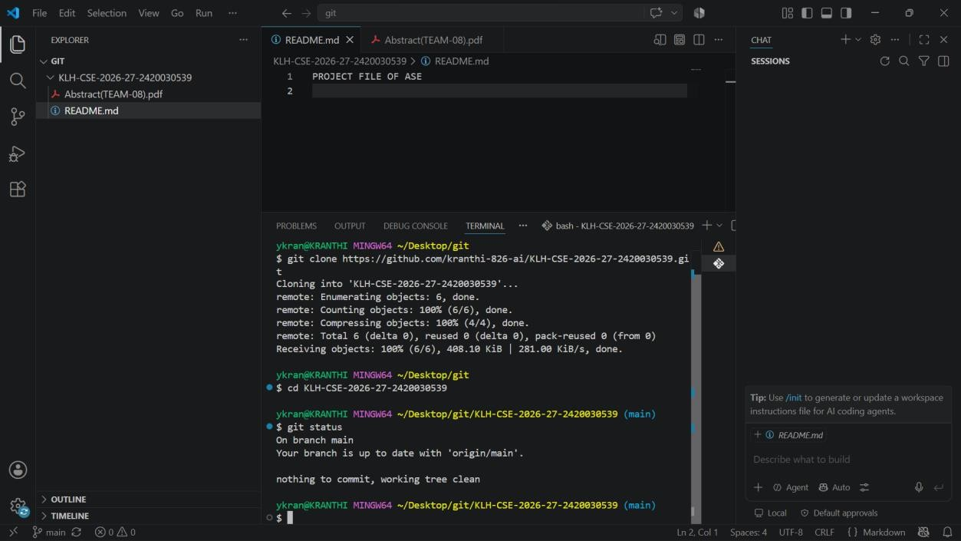
- Push the files using git push.

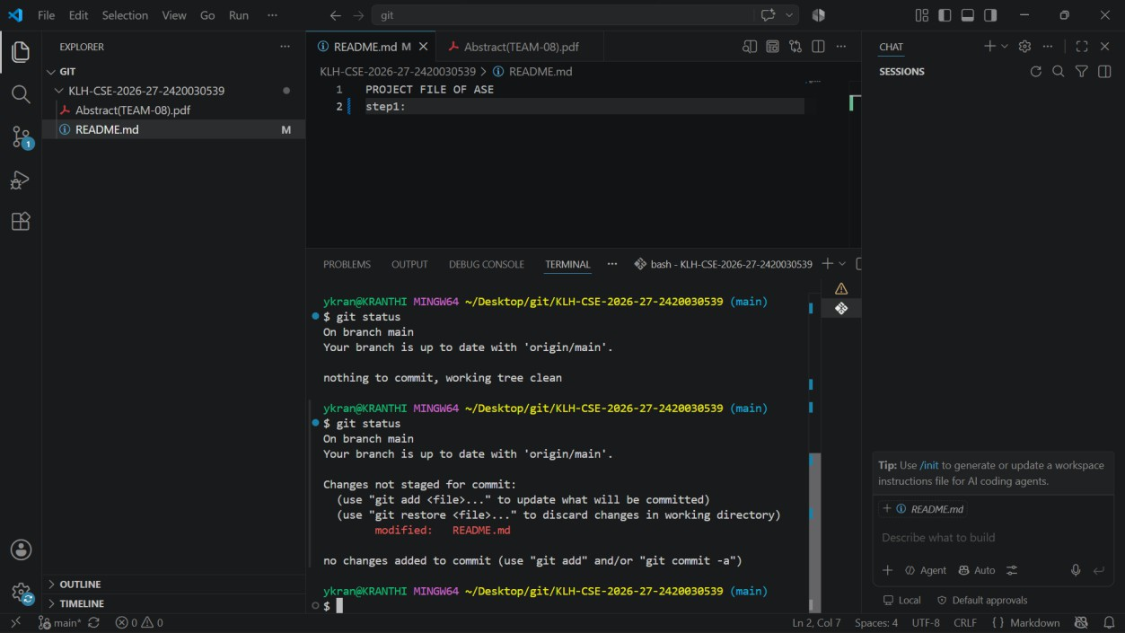
- Git status

- Push the files using git push.

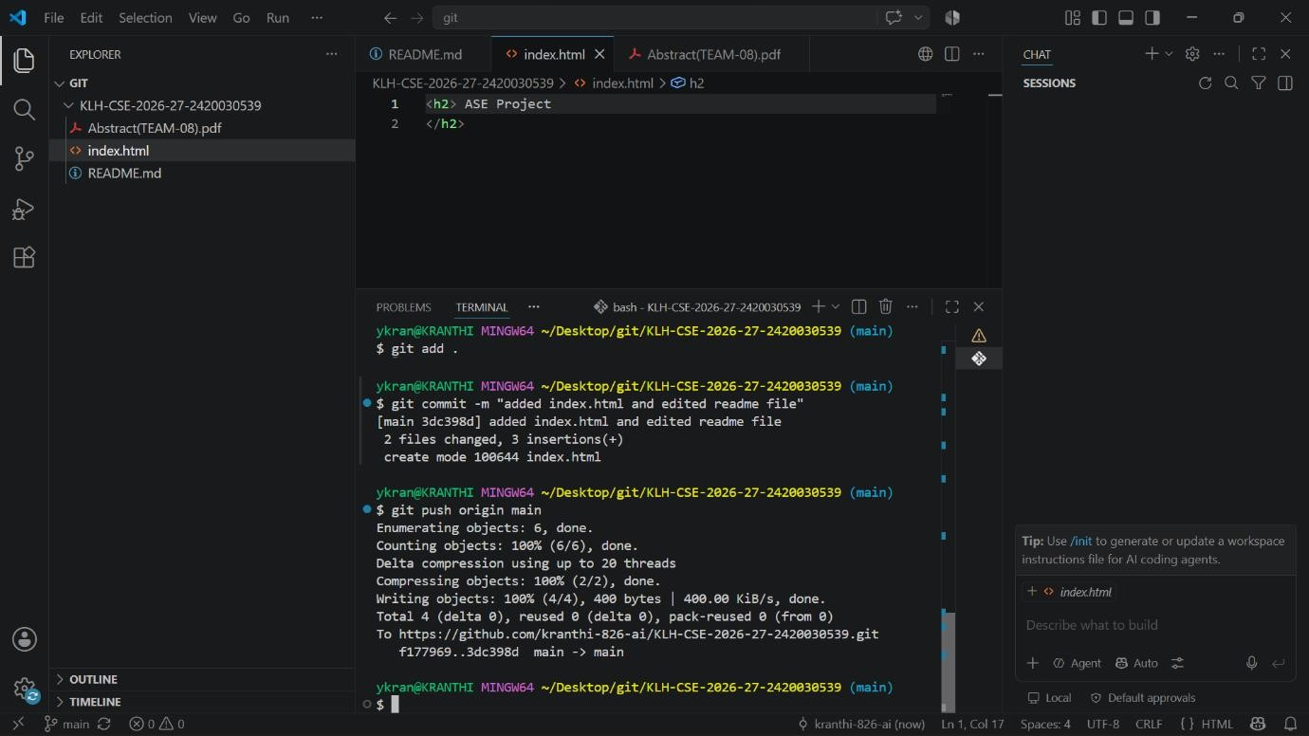
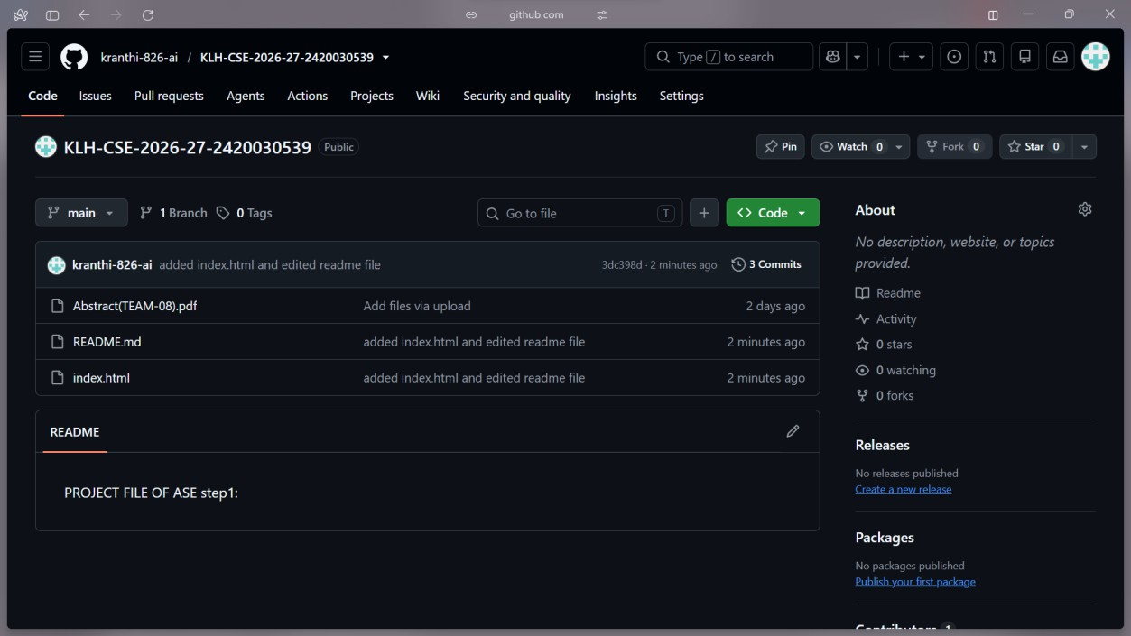
- Check the commits on GitHub.

Outcome:
Successfully learned how to create Git commits and upload a project to GitHub.

